**Transfer Money service:**

This service transfers the amount from one account to another:

Json request format:

Response in the console:Email notification sent to account holders about the balance

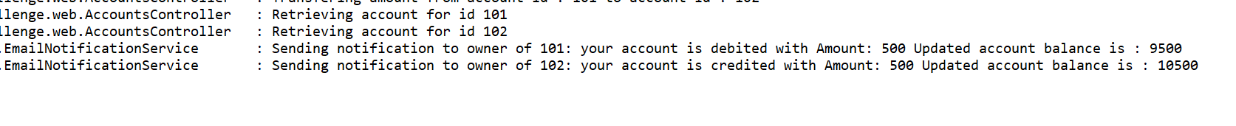

Transfer money: when the sender doesn’t have sufficient balance

Transfer money: when the account Id is not present

Created a POJO AccountTransferMoney for holding the sender and receiver account id

Created custom exceptions to handle NoAccountIdException and LowBalanceException.

Code changes made in AccountsController.java and AccountsRepositoryInMemory.java

**Test case: Positive and negative scenarios**

